Fatima Jinnah Women University

*Department of Software Engineering*



**SUBJECT: CC LAB**

**SUBMITTED TO: SIR SHOAIB**

**SUBMITTED BY: ZUNAIRA NOOR**

**REGISTRATION NO: 2023-BSE-075**

**SEMESTER: V-B**

**Task 0 Lab Setup (Codespace & GH CLI)**

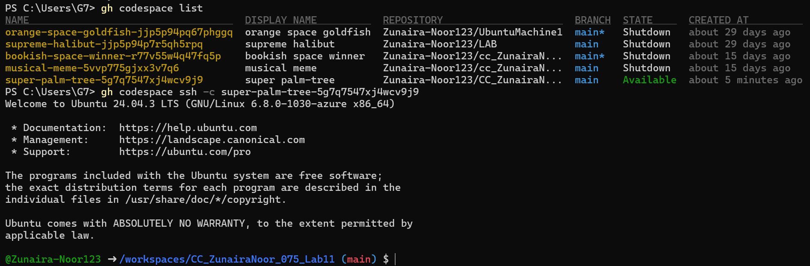

**Task 1 — Provider & Basic variable (variable precedence)**

1. **In Codespace create main.tf:**



1. **Edit main.tf and add provider:**

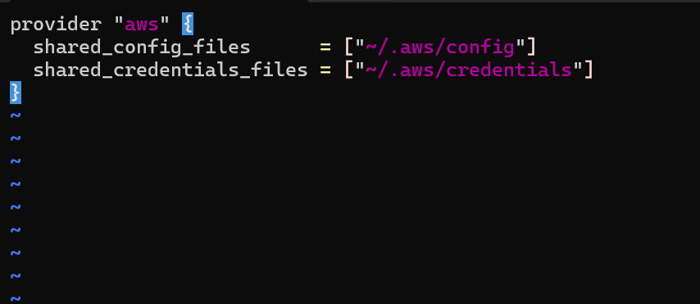

1. Initialize:

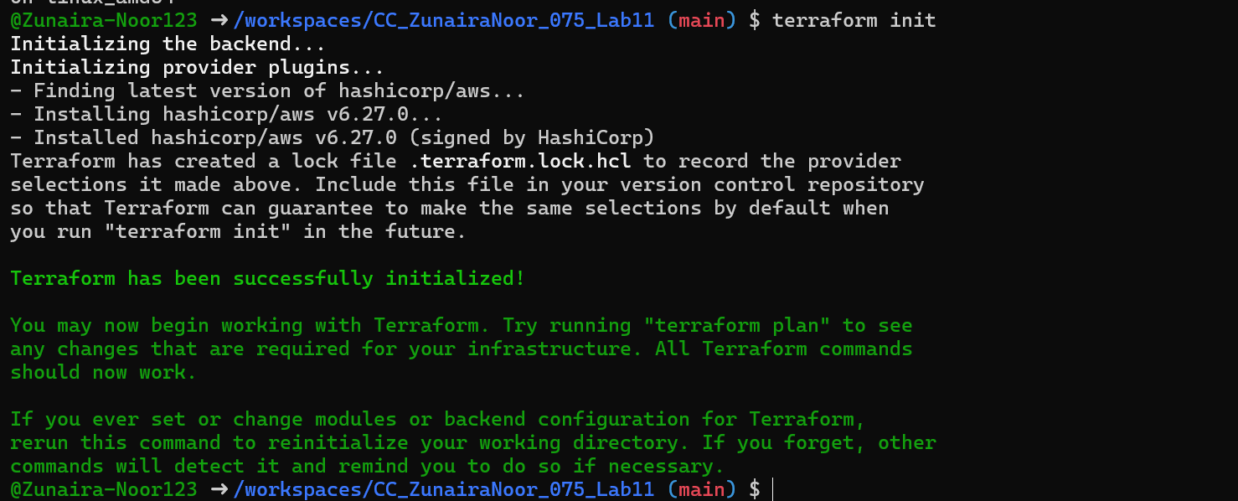

1. Define a variable and output:

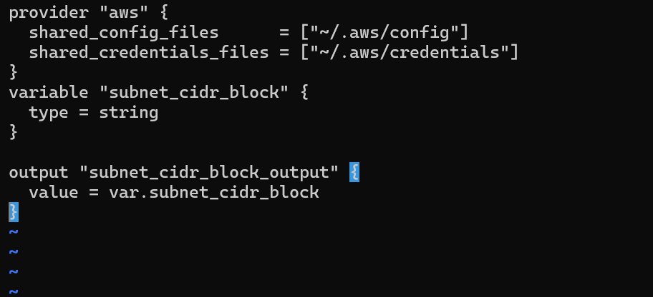

1. Run apply (first time without defaults):

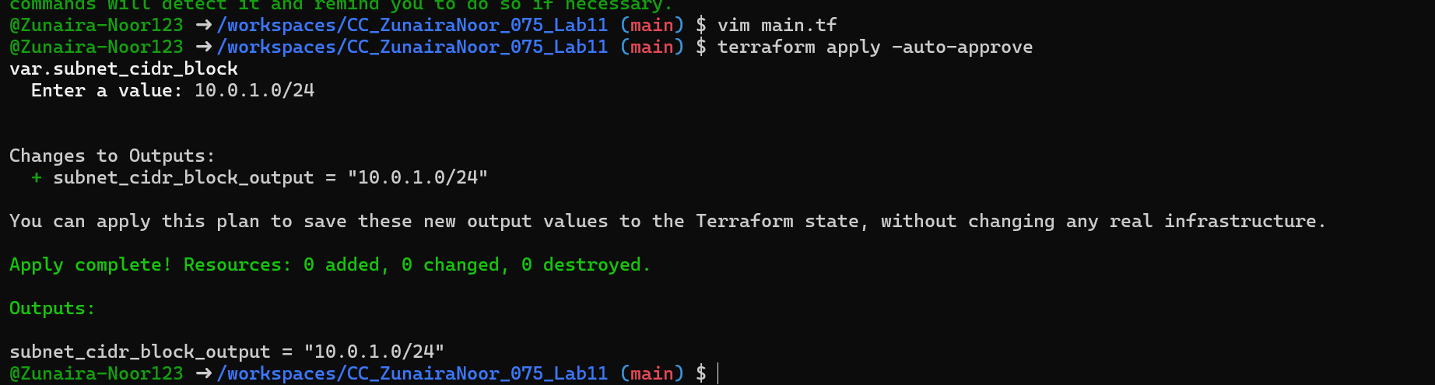

1. Add a default to the variable:

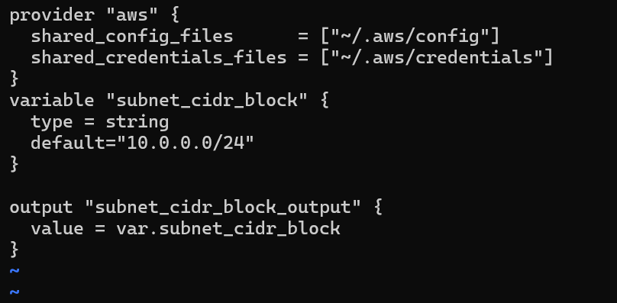

Run:

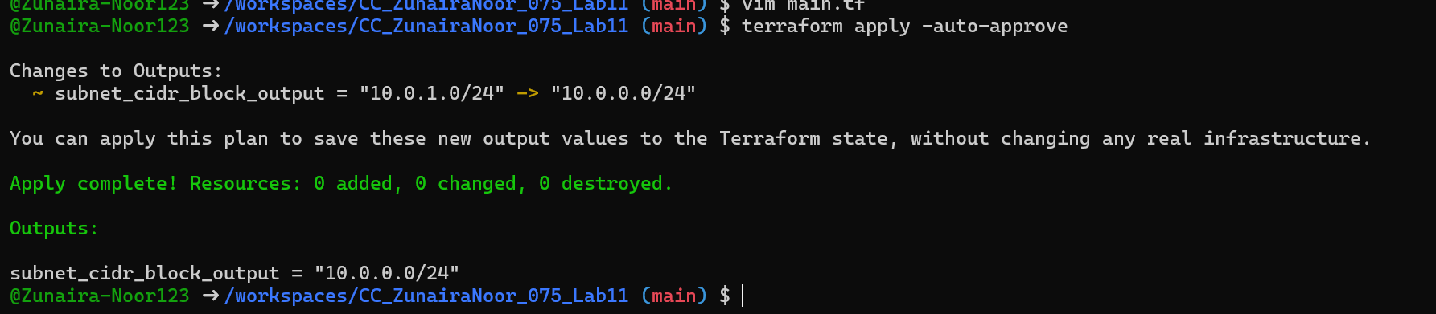

1. Export environment variable in Codespace shell:

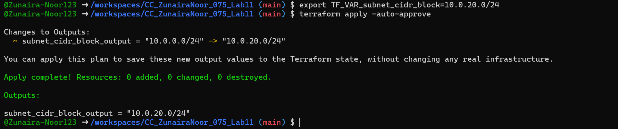

1. Create terraform.tfvars overriding values:

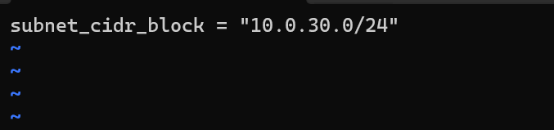

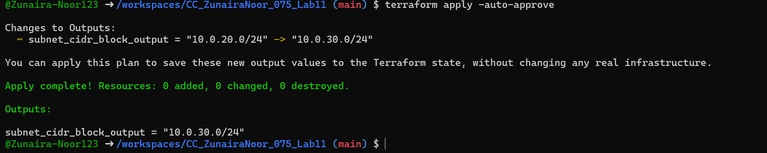

1. Override with -var:

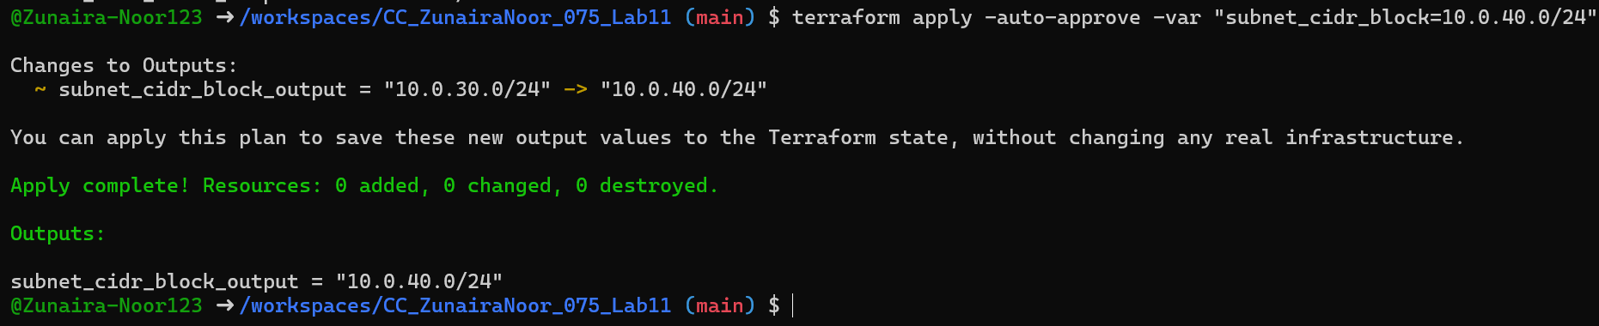

1. Show and unset env var:



**Task 2 — Variable validation & sensitive / ephemeral variables**

1. Replace subnet_cidr_block variable with this (validation included):

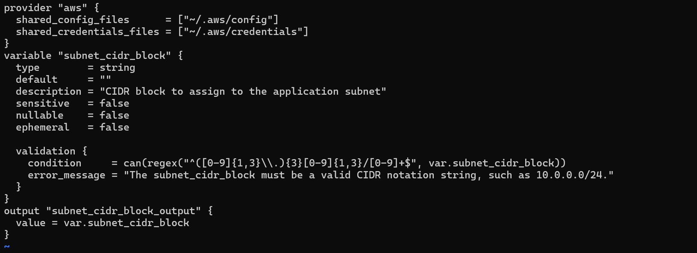

1. Test validation failure:

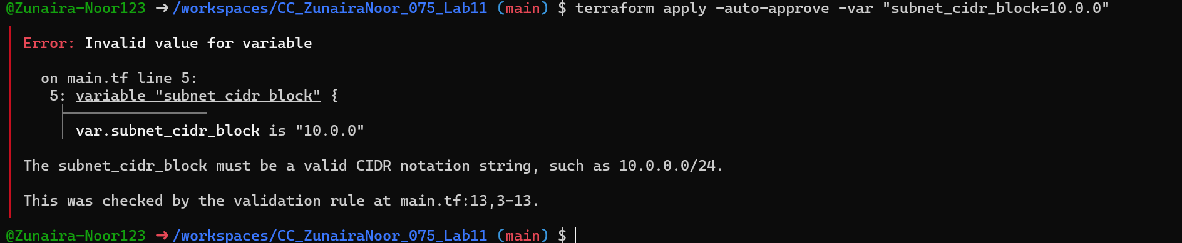

1. Create a sensitive variable api_session_token and output (sensitive):

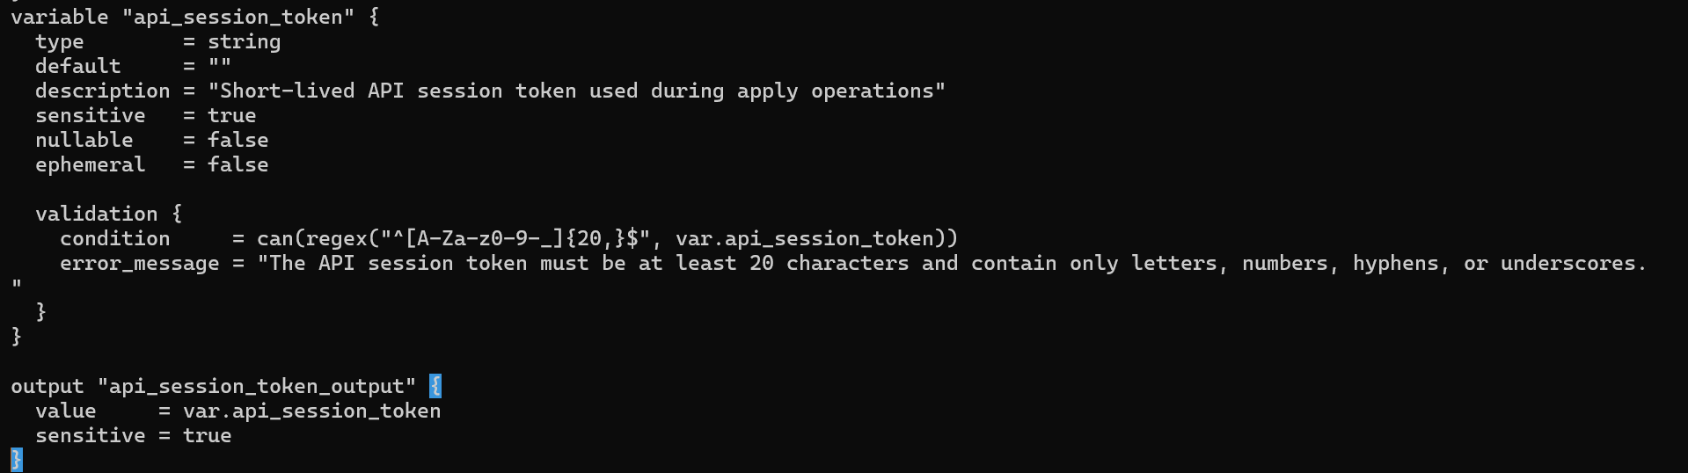

1. Run with -var to observe sensitive output behavior:

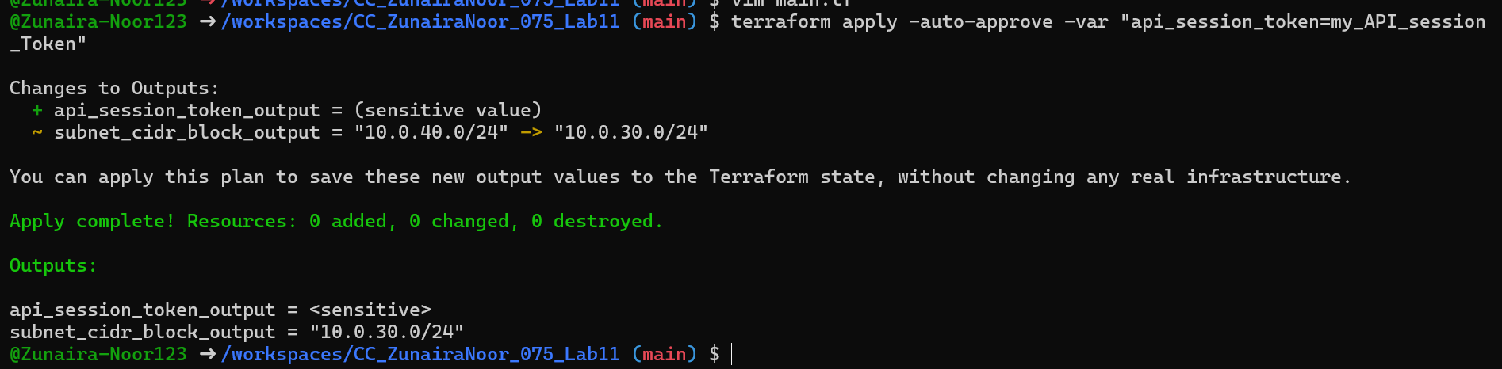

1. Check terraform.state for the sensitive output:

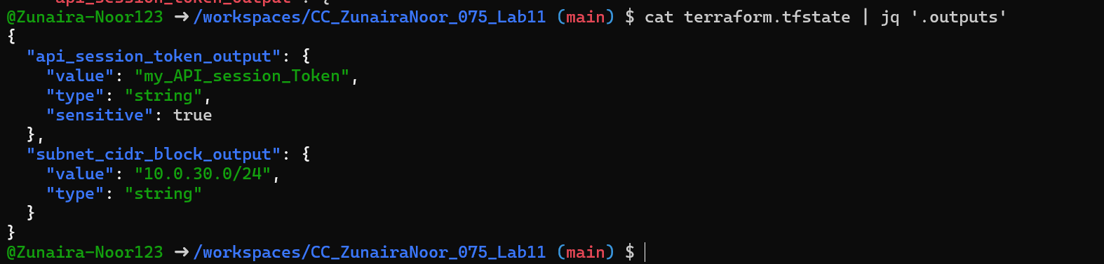

1. Make variable ephemeral to hide from state:

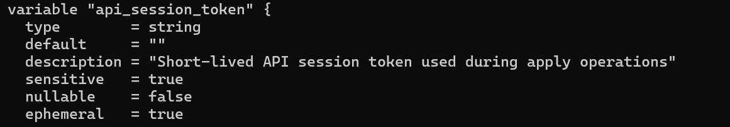

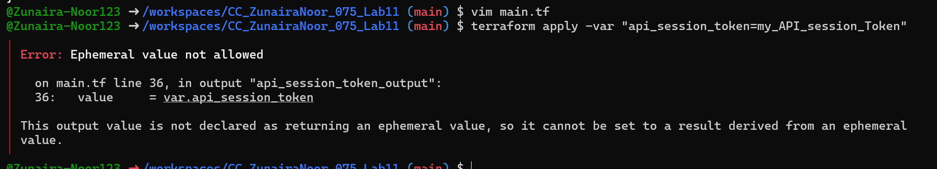

1. Set default to test local default:

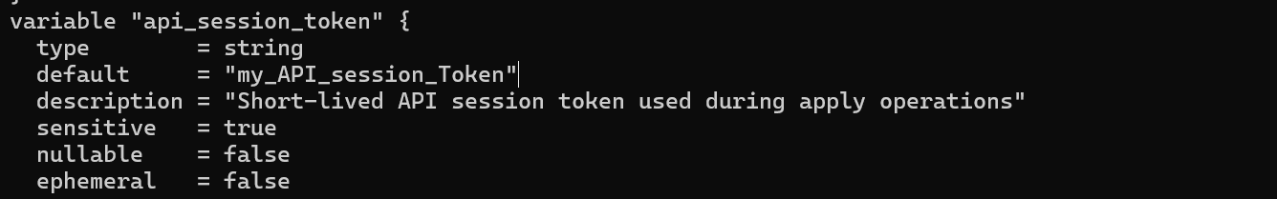

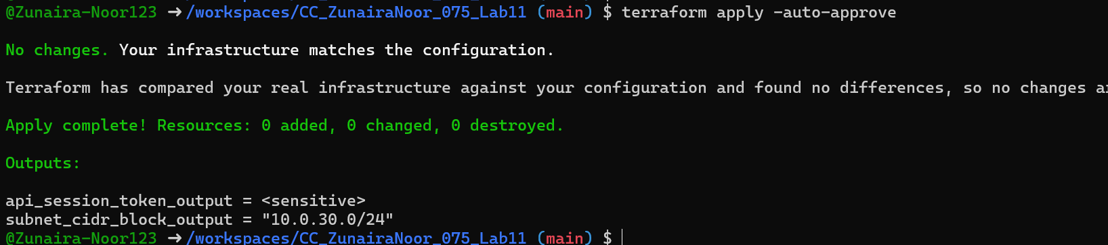

**Task 3 — Project-level variables, locals, and outputs**

1. **Add variables to main.tf:**

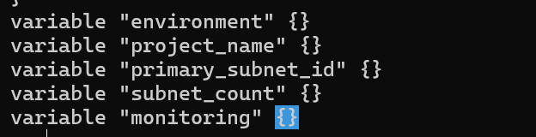

1. Populate terraform.tfvars *after* discovering actual subnet id for availability zone me-central-1a:

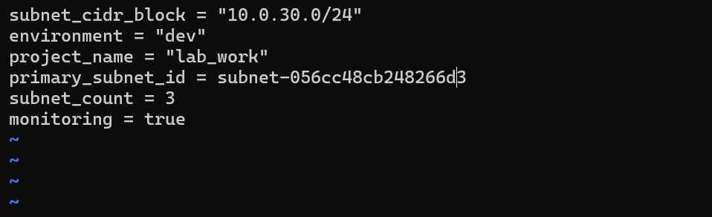

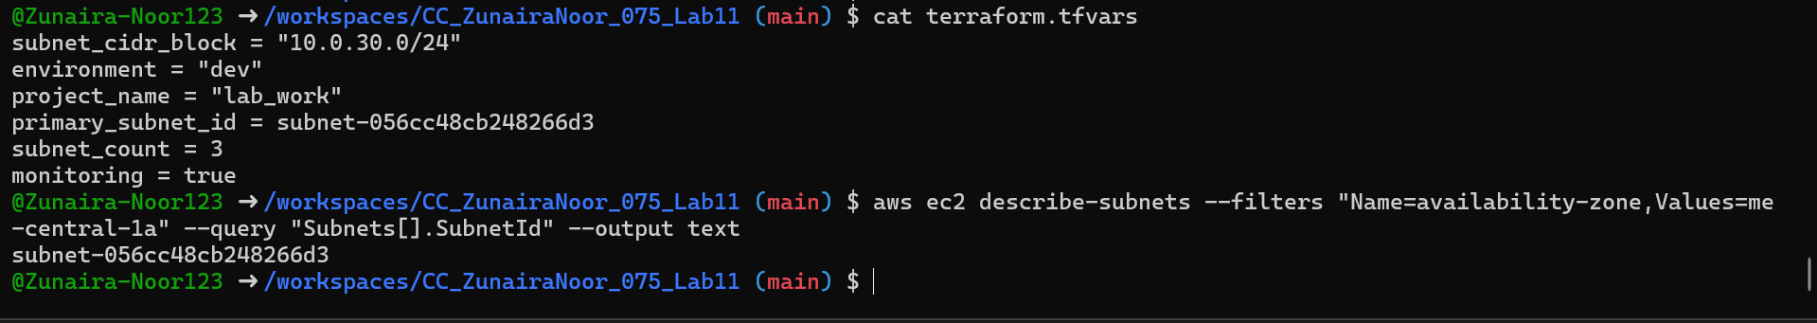

1. Create locals.tf with:

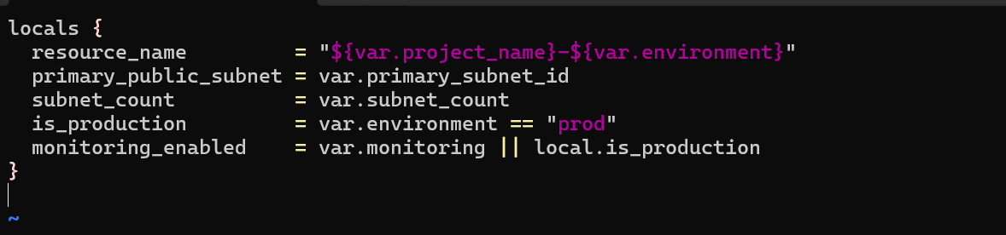

1. Add outputs to main.tf:

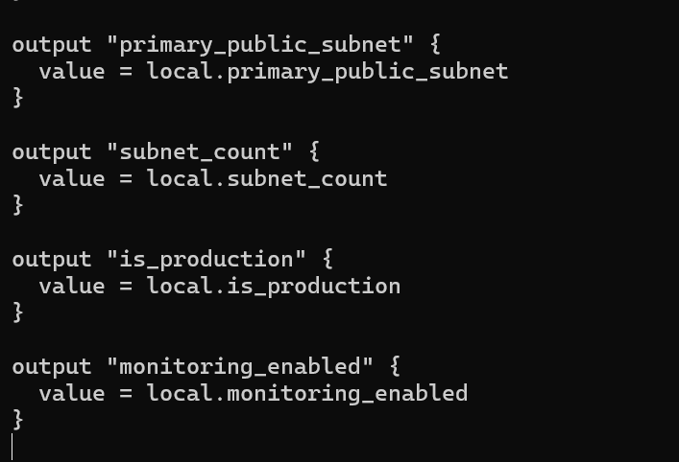

* Run:

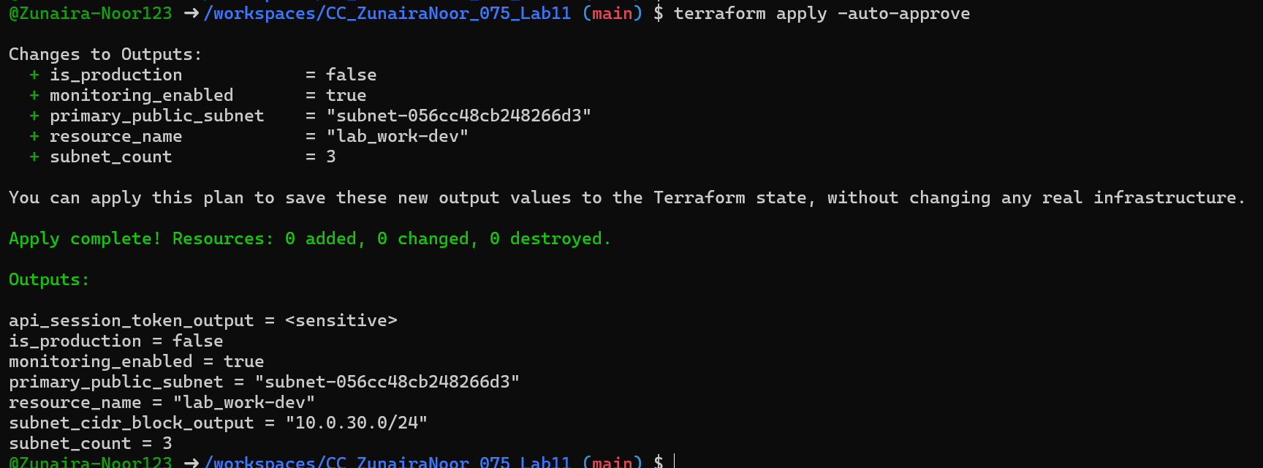

**Task 4 — Maps and Objects**

1. Map variable in main.tf:

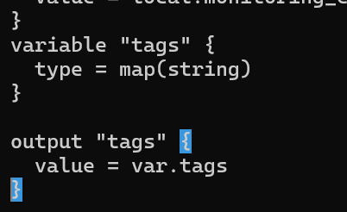

1. In terraform.tfvars:

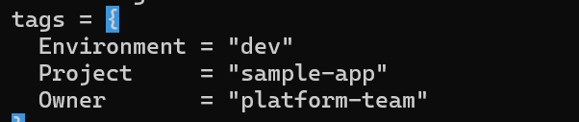

terraform apply -auto-approve

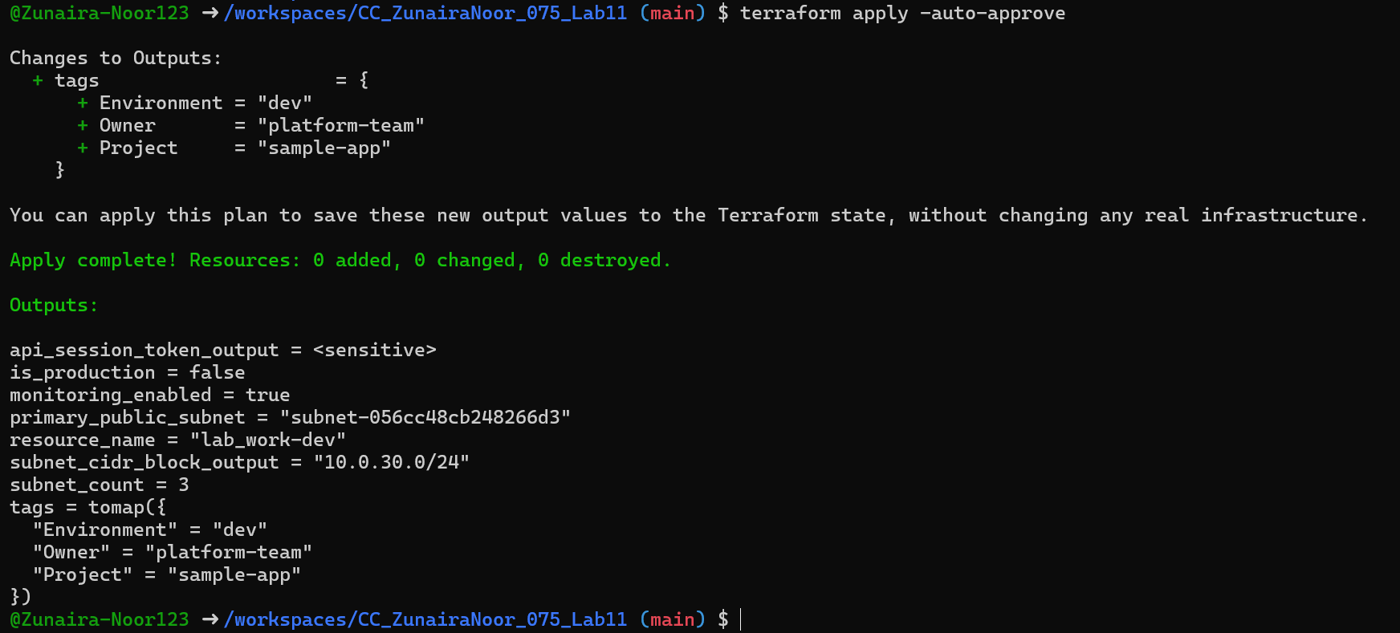

1. Define object variable:

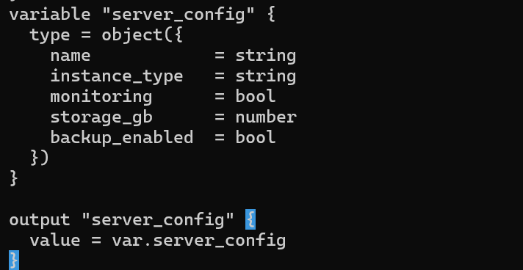

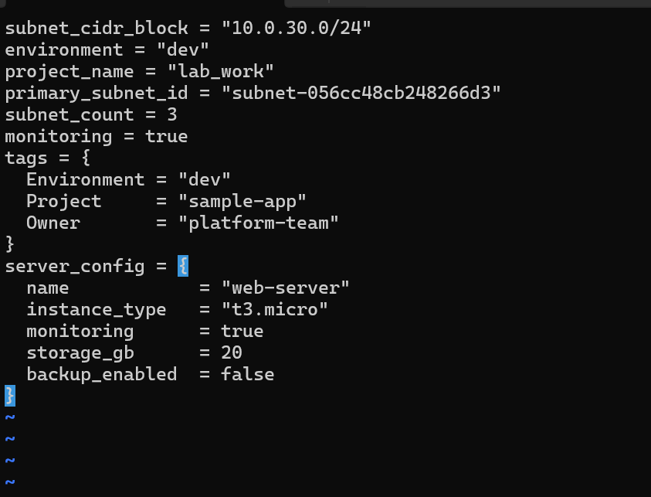

Output showing server_config object.

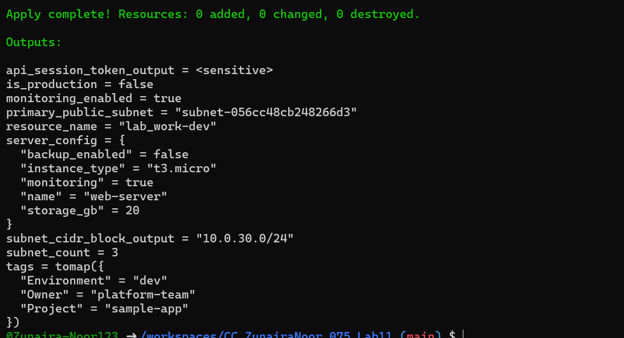

**Task 5 — Collections: list, tuple, set & mutation via locals**

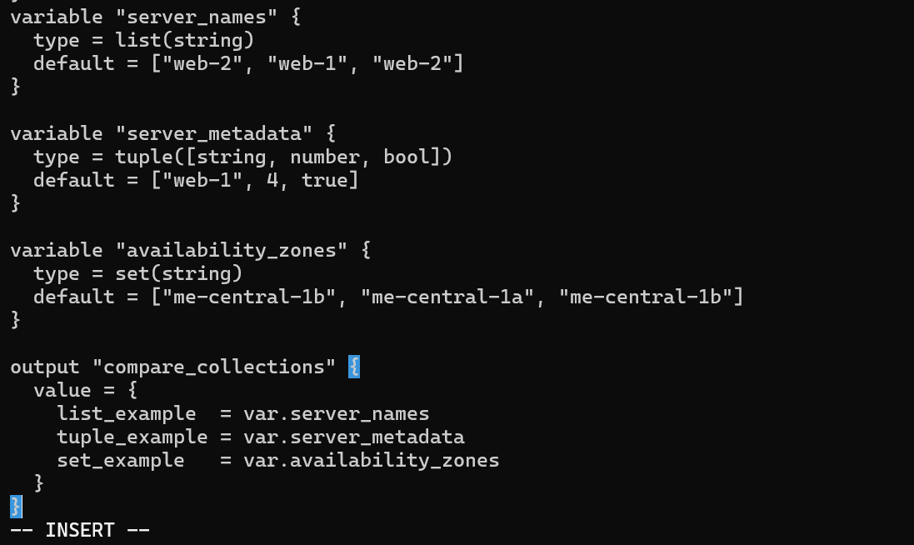

1. **Run:**

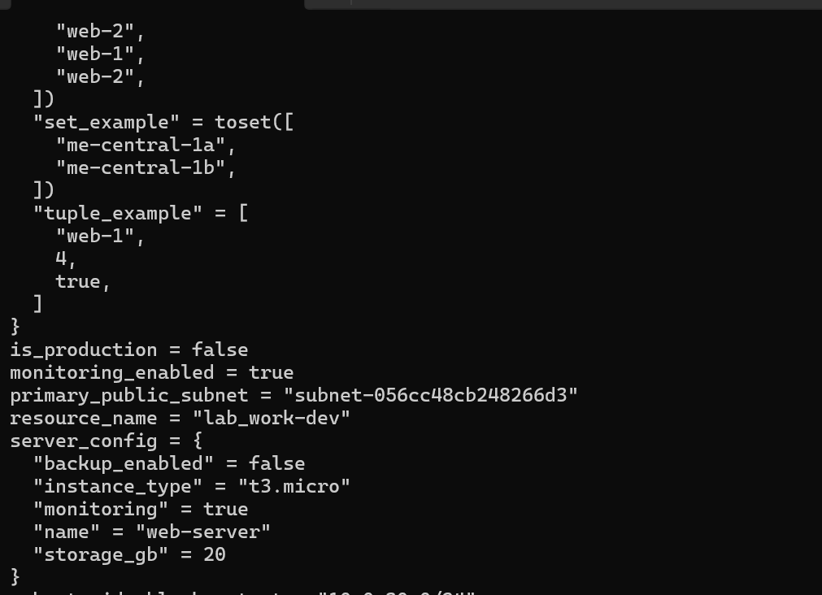

**In locals.tf add mutations: Create or edit locals.tf and add the following locals to demonstrate mutation behavior**

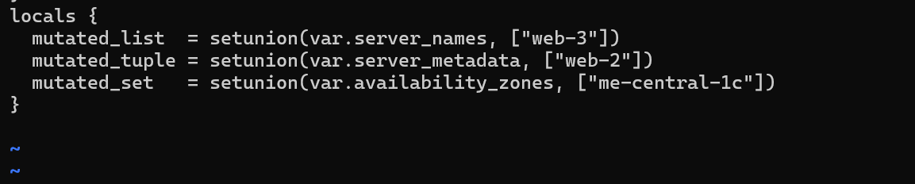

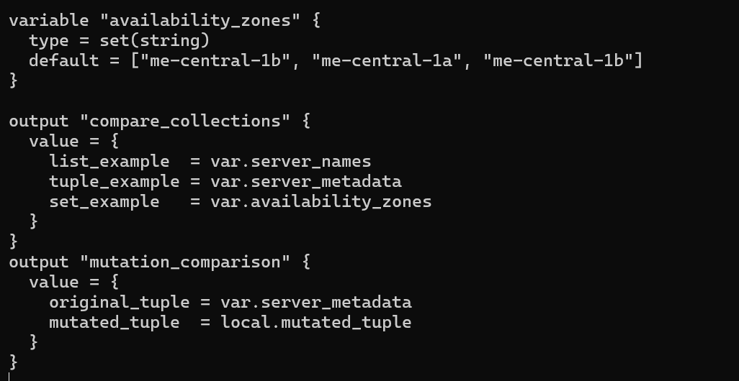

**Apply Terraform**

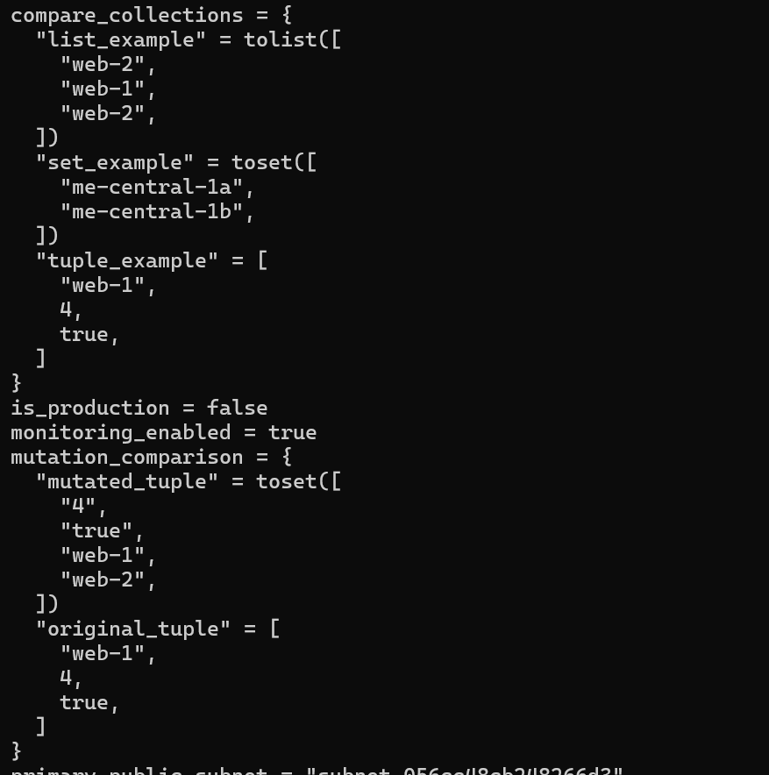

**Task 6 — Null, any type & dynamic values**

1. **Null variable:**

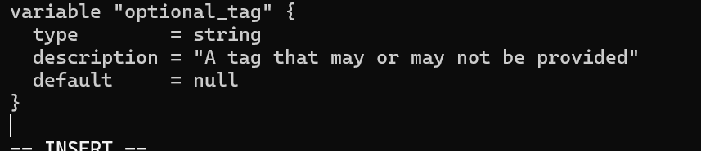

1. **Merge tags in locals.tf:**

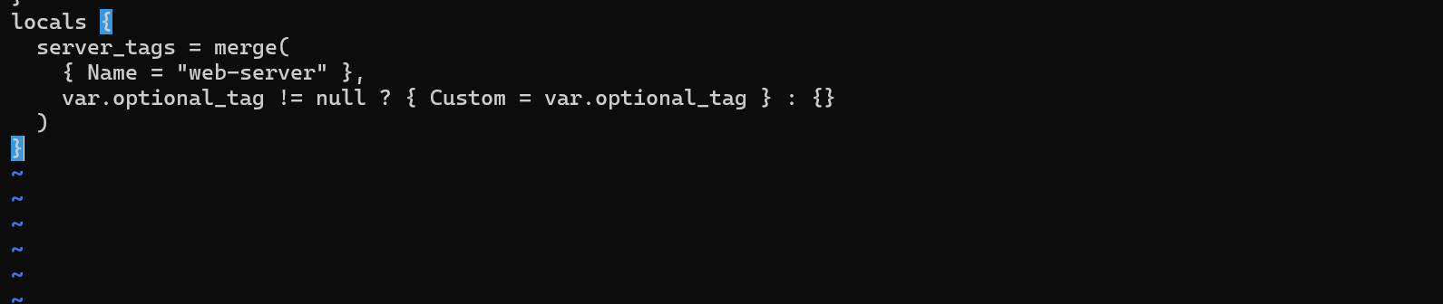

1. **Output:**

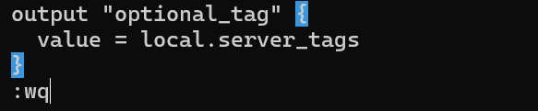

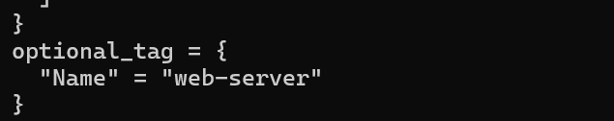

1. **Add in terraform.tfvars:**

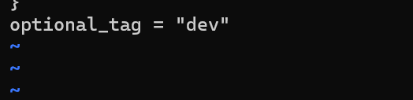

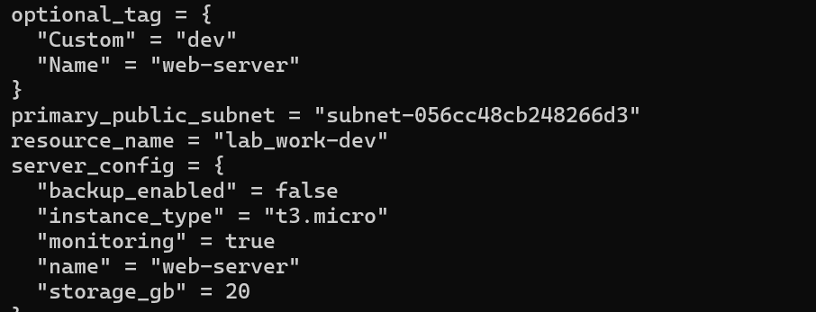

1. **Any type variable:**

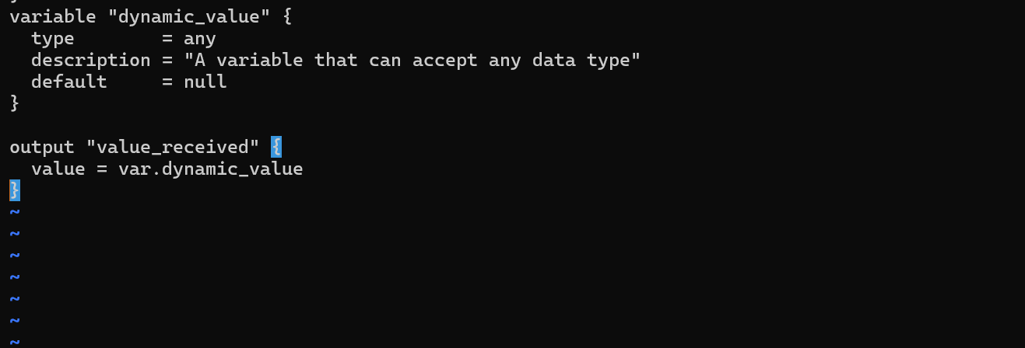

**a) String**

* **In terraform.tfvars:**

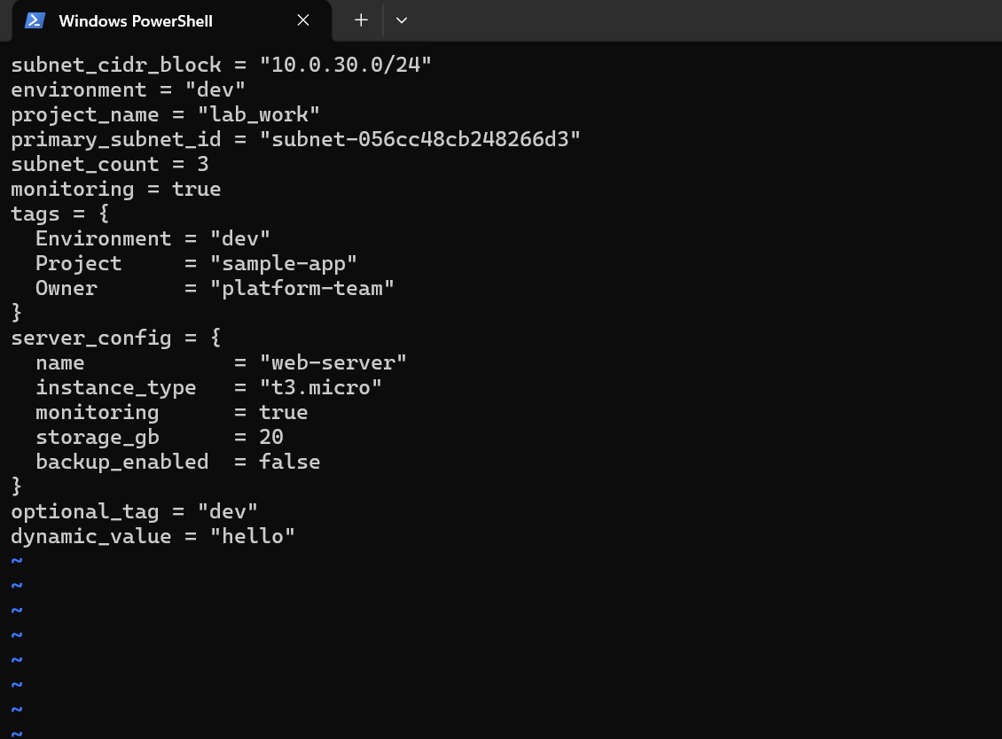

* **Run:**

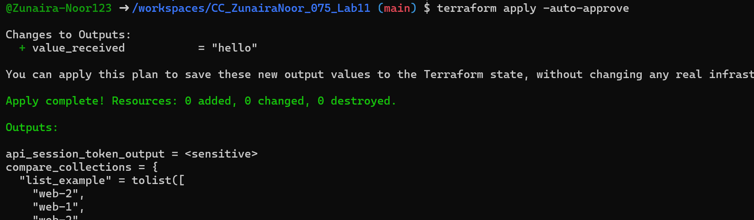

**b) Number**

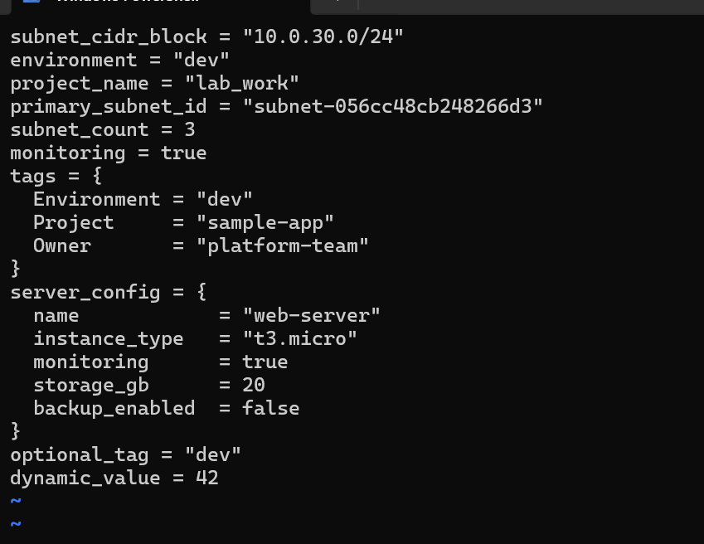

* **Run:**

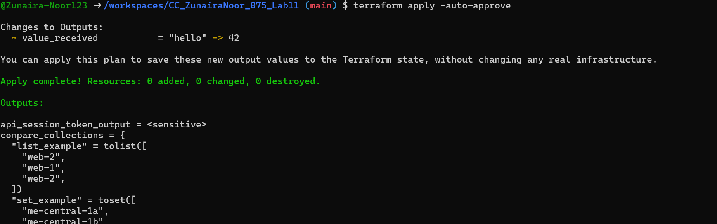

**c) List**

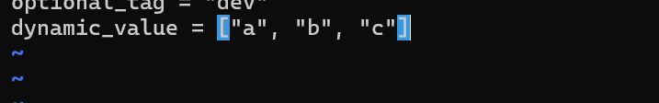

* **Run:**

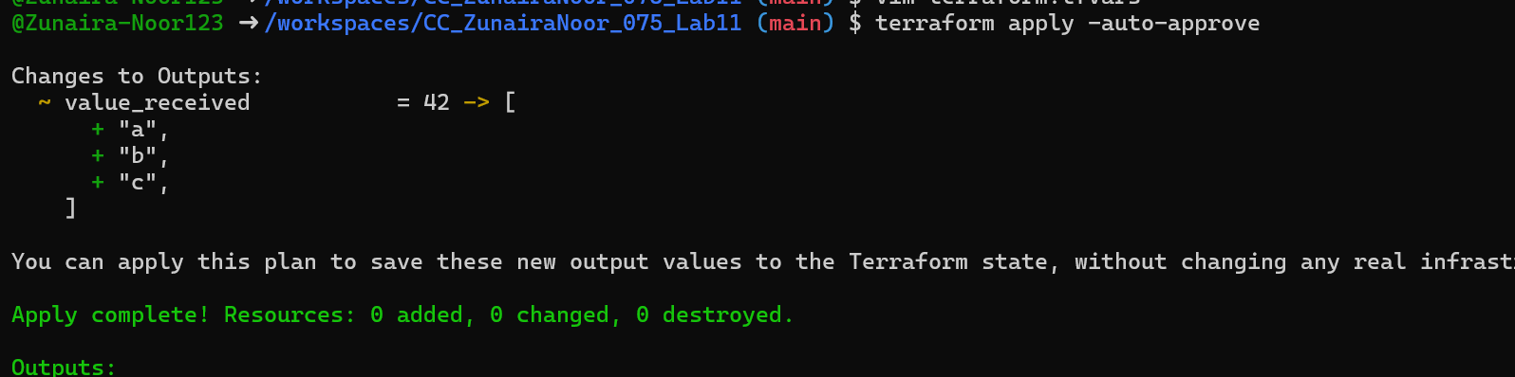

**d) Map / Object**

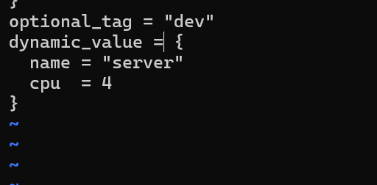

* **Run:**

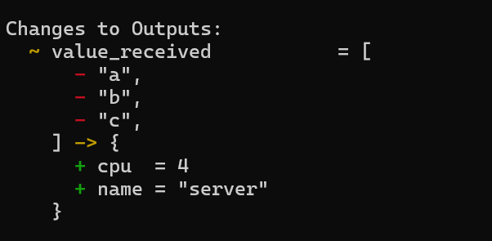

**e) Null**

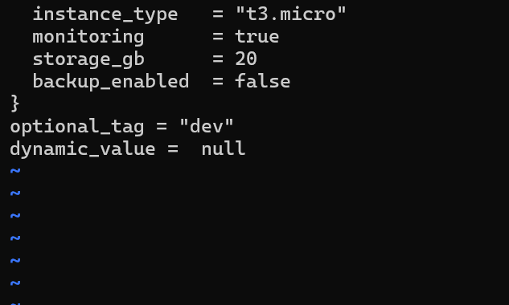

* **Run:**

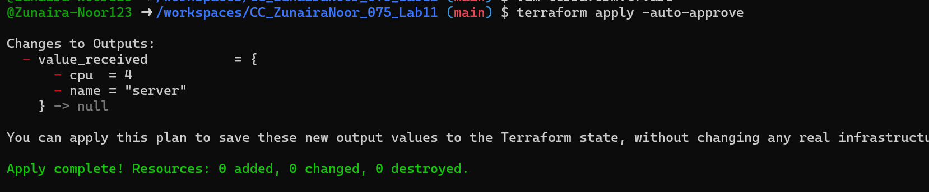

**Task 7 — Git ignore**

**Create .gitignore:**

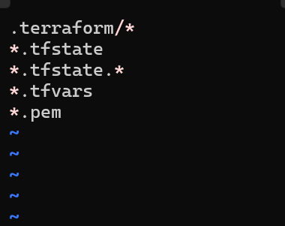

**.gitignore file content showing entries.**

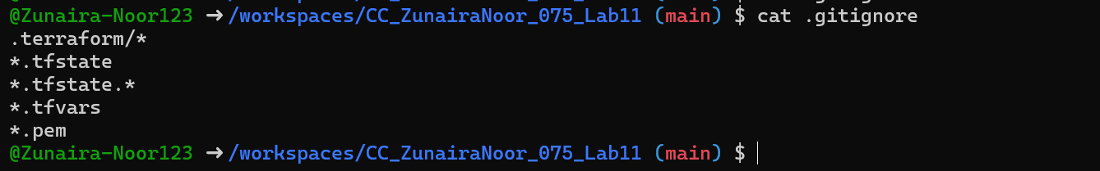

**Task 8 — Clean-up then build real infra**

1. **Clean previous files**



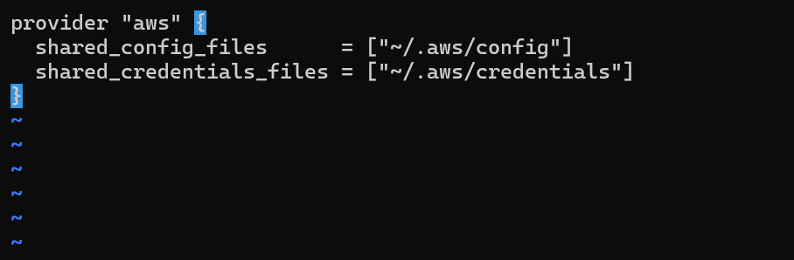

1. **Define variables in main.tf Add these variable declarations to main.tf (below the provider block):**

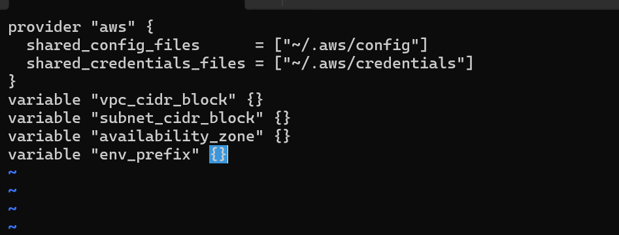

1. **Create VPC in main.tf Add the VPC resource to main.tf:**

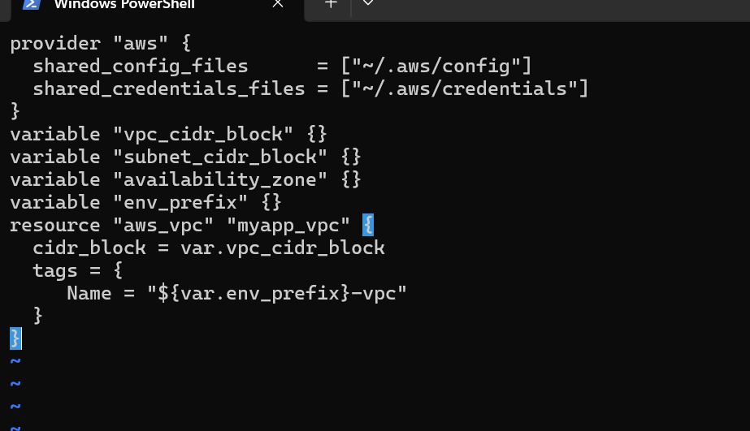

1. **Create Subnet in the VPC Add the subnet resource to main.tf:**

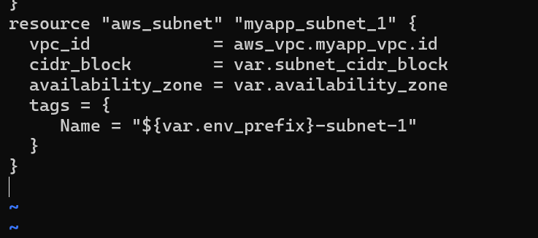

1. Populate terraform.tfvars In terraform.tfvars add:

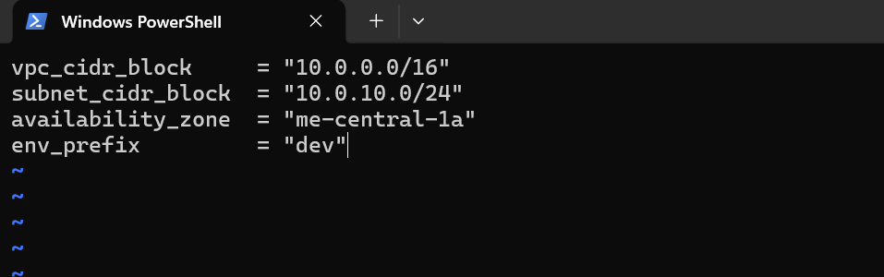

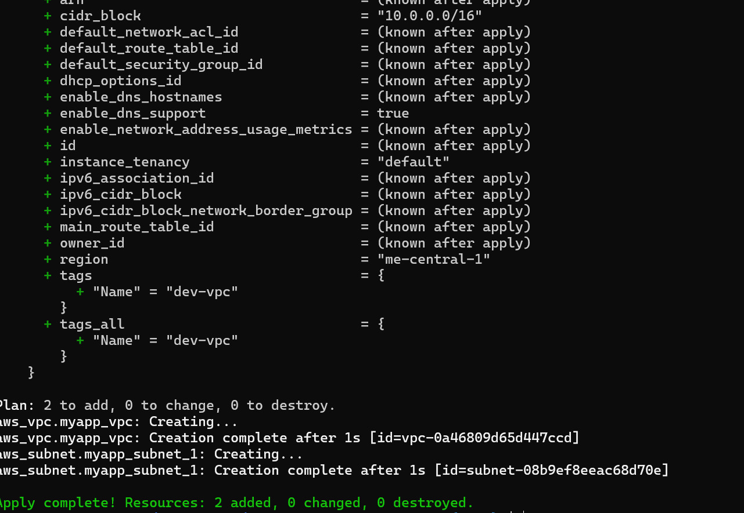

Verify in AWS Console that the VPC and Subnet were created.

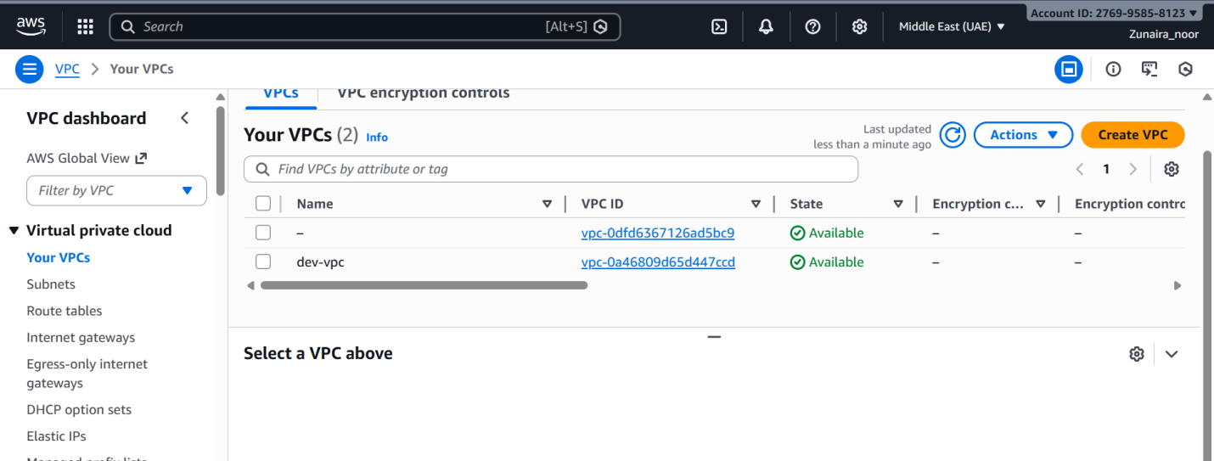

1. **Create Internet Gateway and Route Table (custom) Add the Internet Gateway and a custom Route Table to main.tf:**

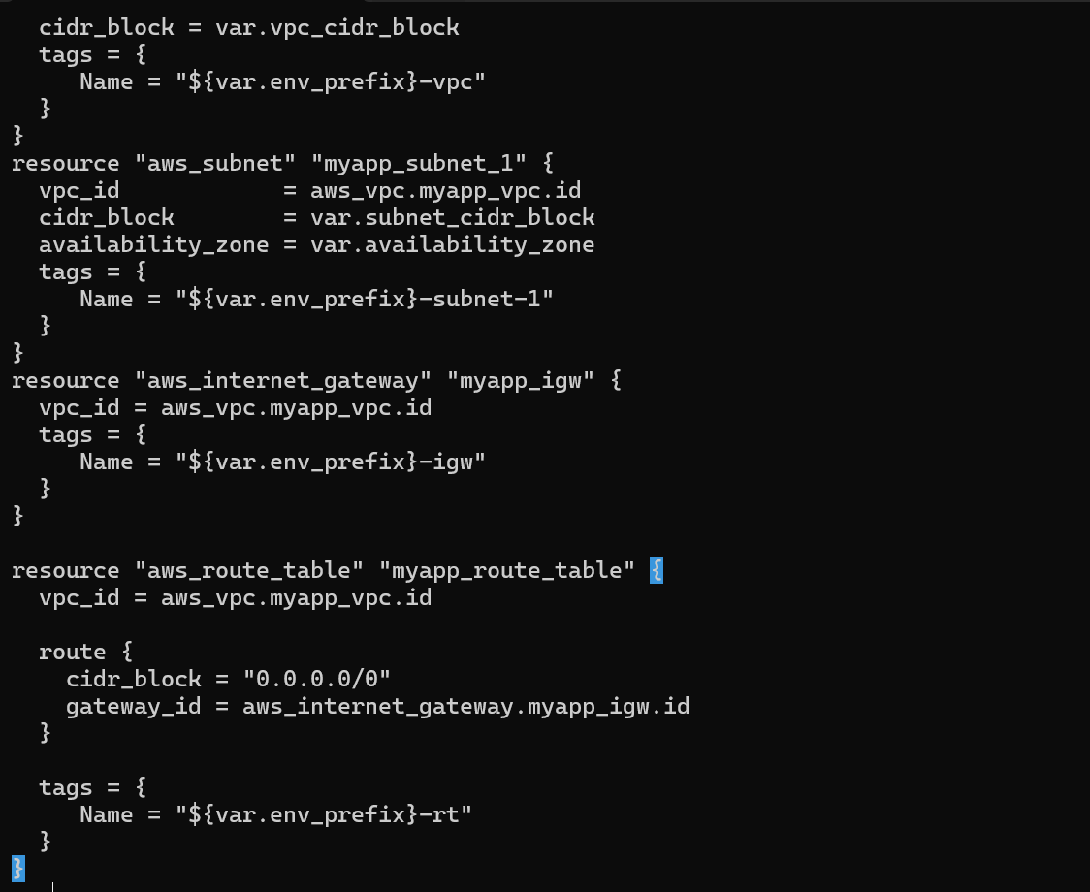

**AWS console showing IGW and route table resources (before apply).** 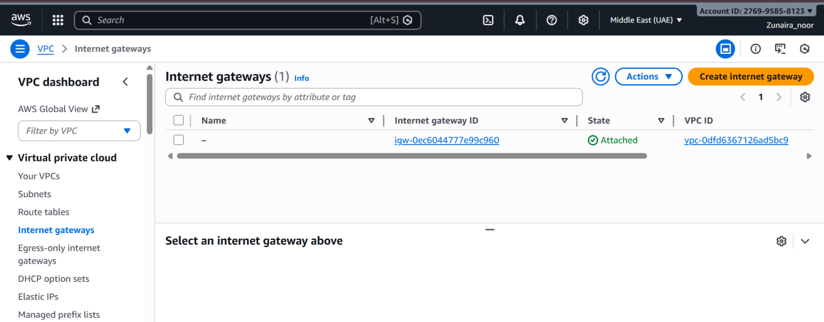

**Verify IGW and route table in AWS Console.**

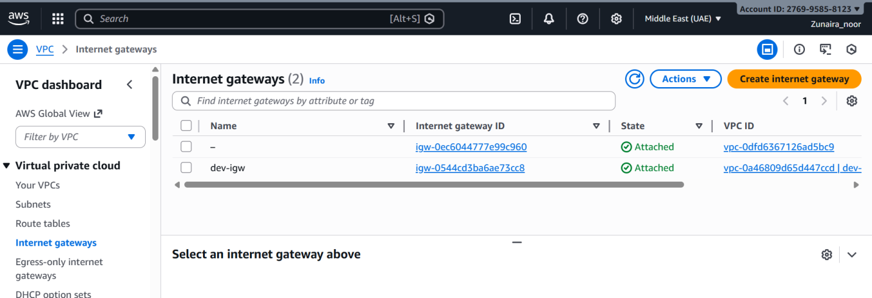

1. **Associate the Route Table with the Subnet Add the association resource to main.tf:**

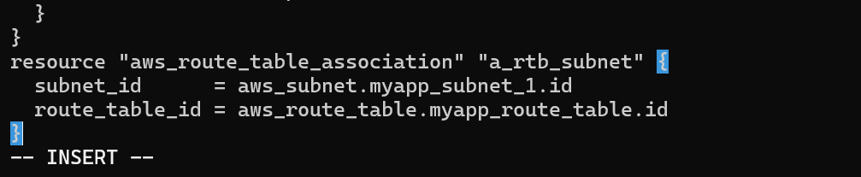

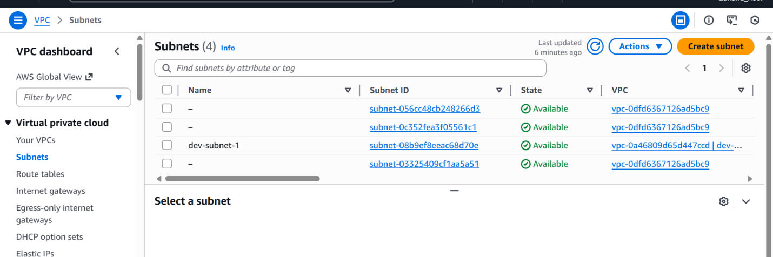

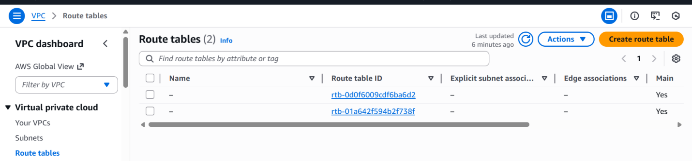

1. **Switch to default route table (use VPC default route table) Now remove (or comment out) the custom route table and association resources from main.tf:**

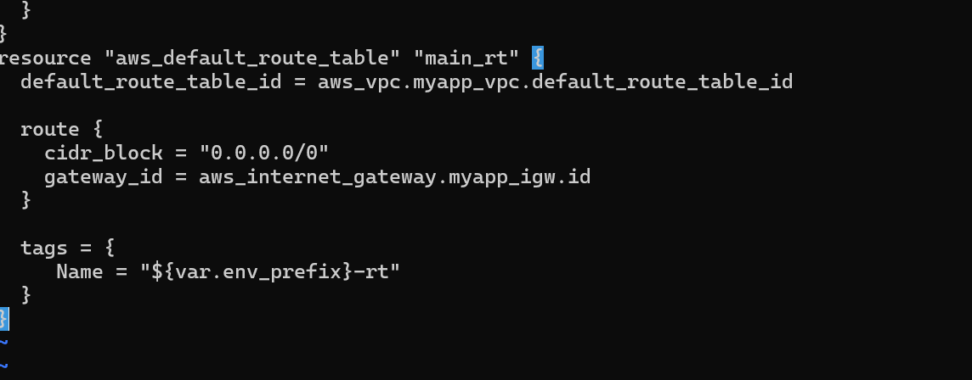

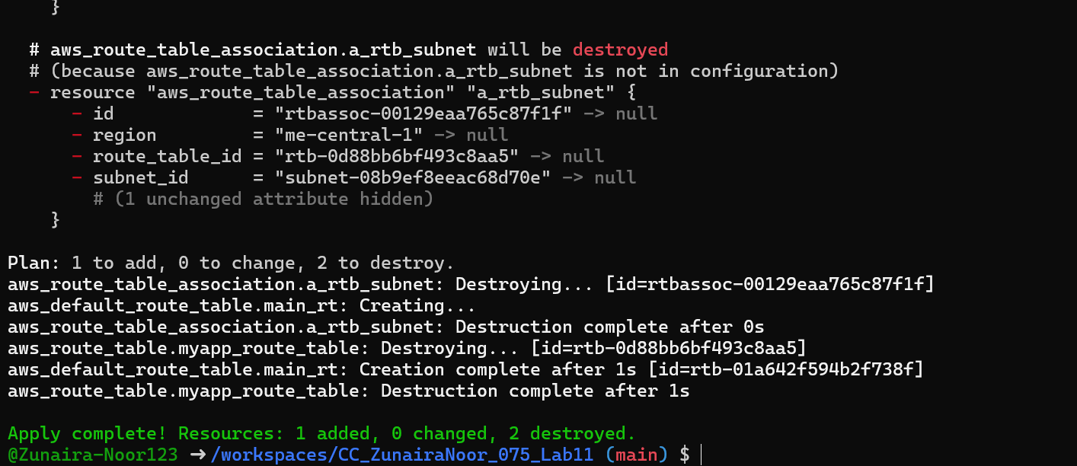

**Verify in AWS Console (MANDATORY)**

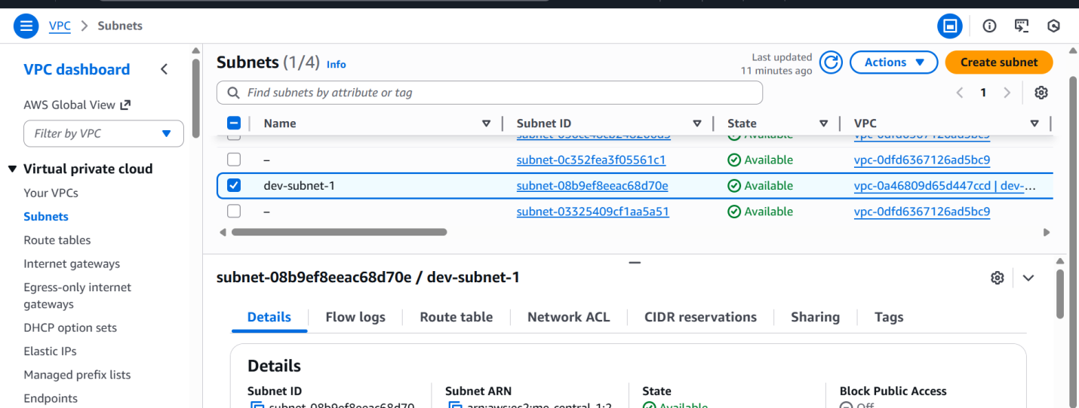

**Task 9 — Security Group, Key Pair, EC2 Instance, user_data & nginx**

1. **Add variables to main.tf Add these variables to your main.tf:**

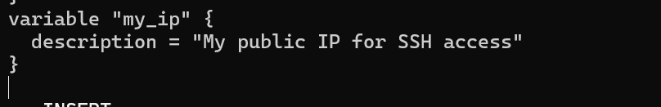

1. Get your public IP and set terraform.tfvars From the Codespace shell:



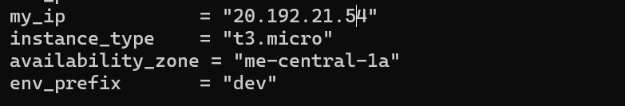

**Create the Security Group (main.tf) Add this resource to main.tf**

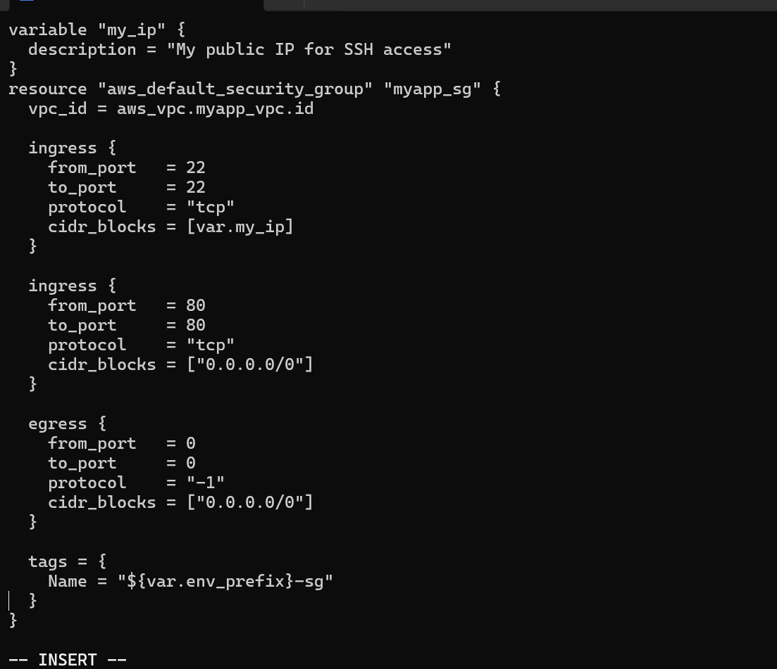

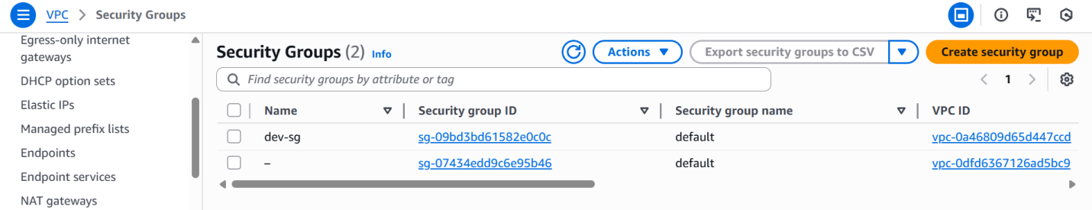

**Run apply:**

1. **Create an AWS key pair and save locally Create a key pair and store the private key in your Codespace. Do NOT commit the .pem file.**



**Ensure .gitignore contains:**

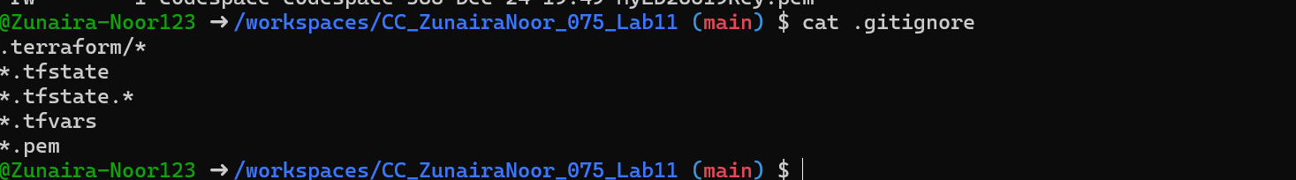

1. **Add EC2 instance resource (initial) Add the instance resource to main.tf (initially using the created key name):**

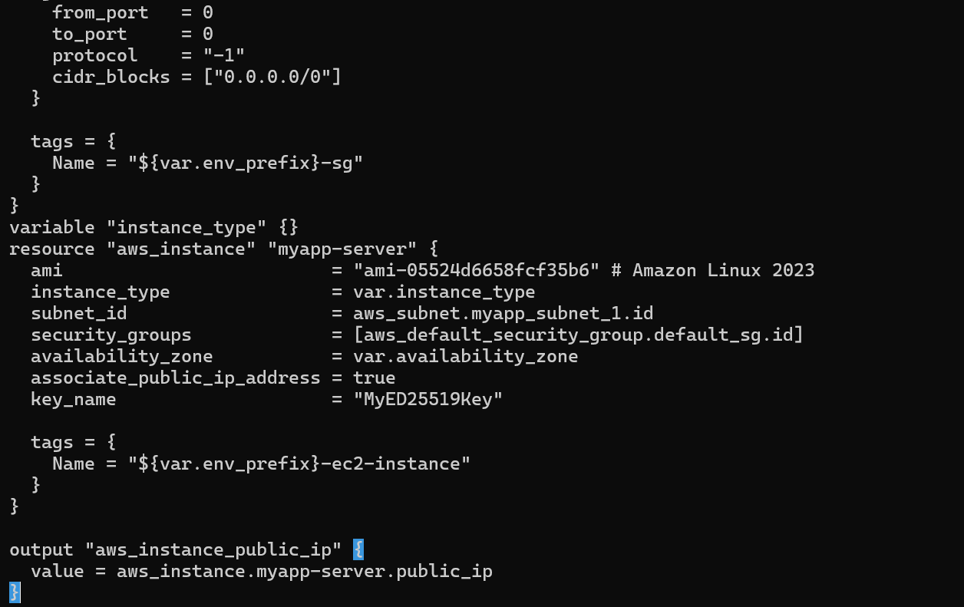

**Run:**

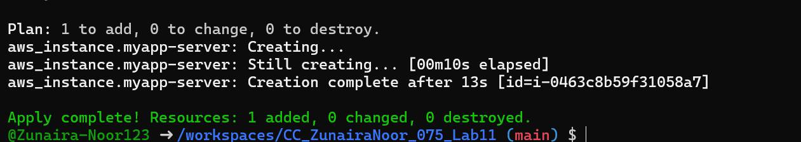

1. **SSH into the instance (using MyED25519Key) From the Codespace:**

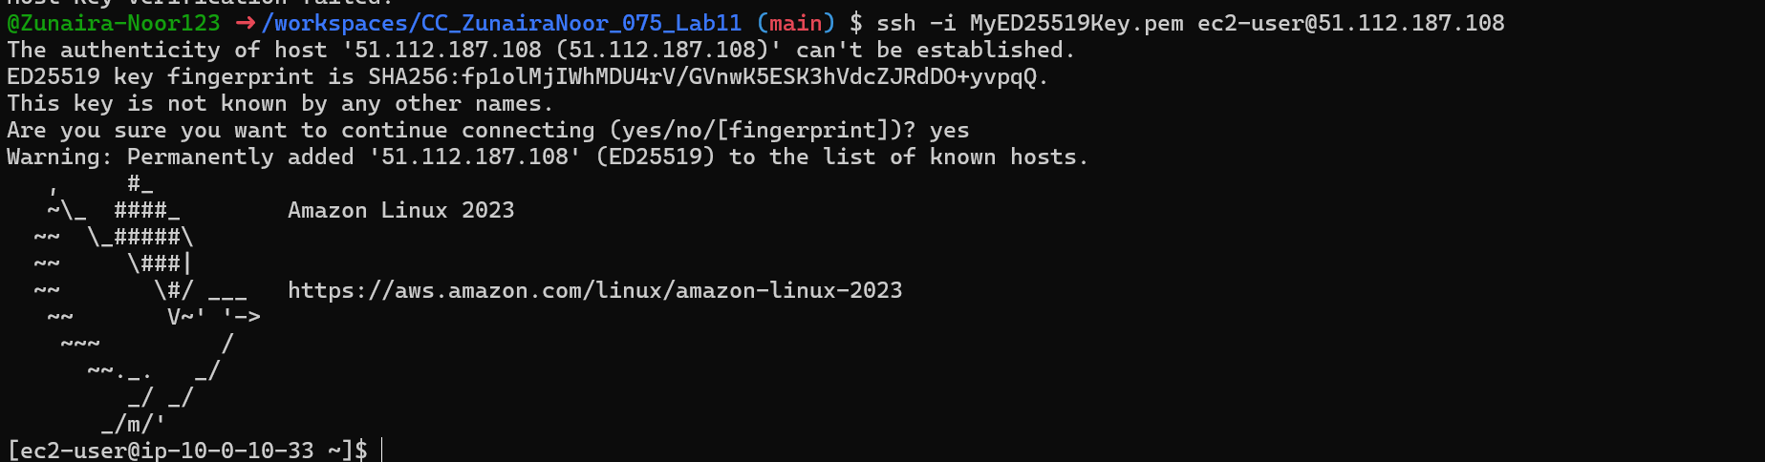

1. **Generate a local SSH keypair and register it in AWS via Terraform On your Codespace, generate an SSH key pair (accept defaults or specify path):**

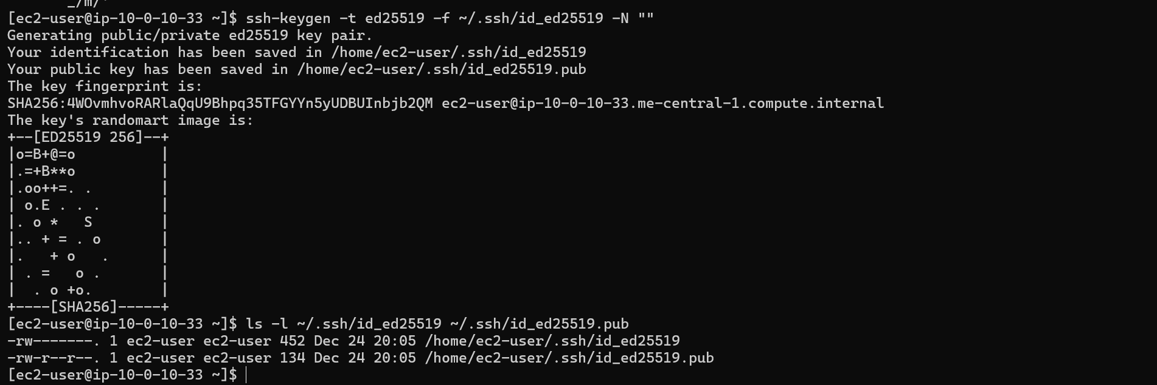

**Add a Terraform resource in main.tf to register the public key:**

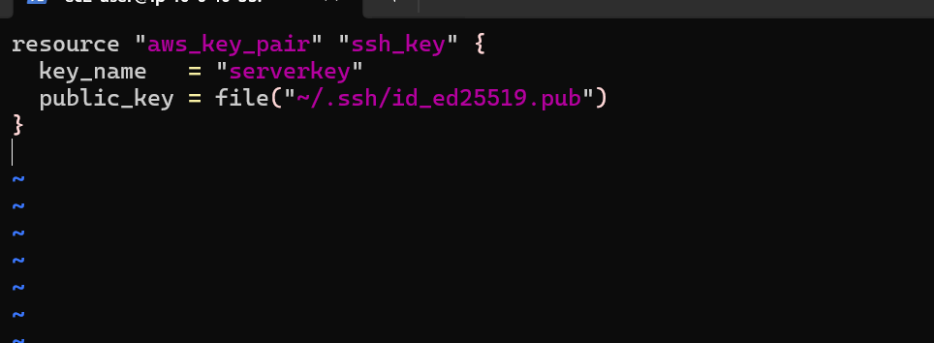

Update the EC2 resource to use the Terraform-managed key:

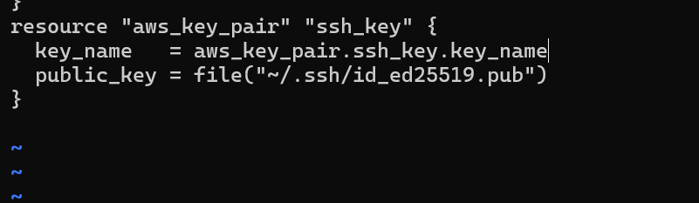

Run:

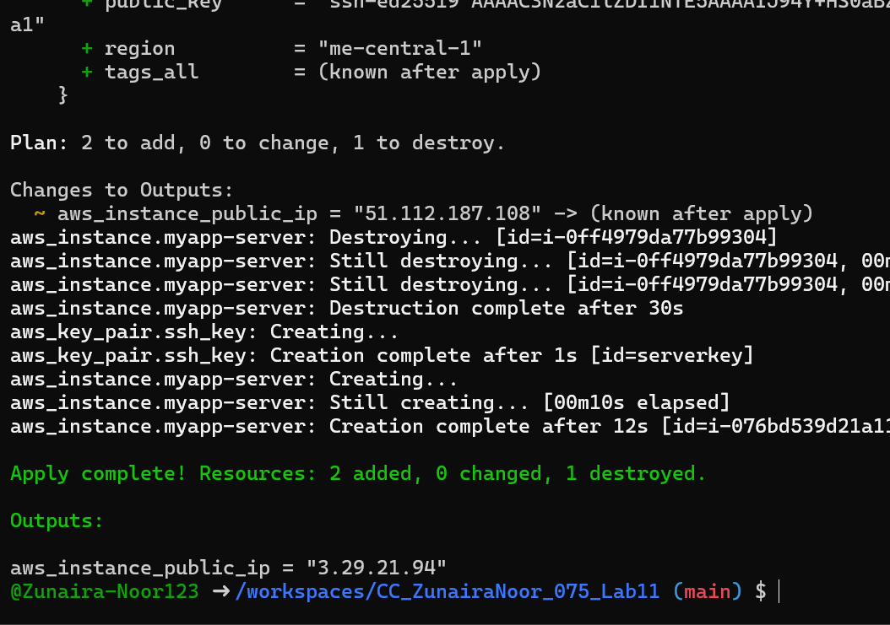

1. SSH using the newly registered key Now SSH with your generated private key (the default ssh client will pick up ~/.ssh/id_ed25519):

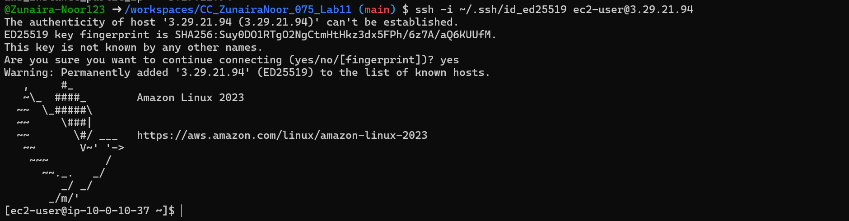

1. Install nginx via inline user_data Modify the aws_instance resource to include inline user_data:

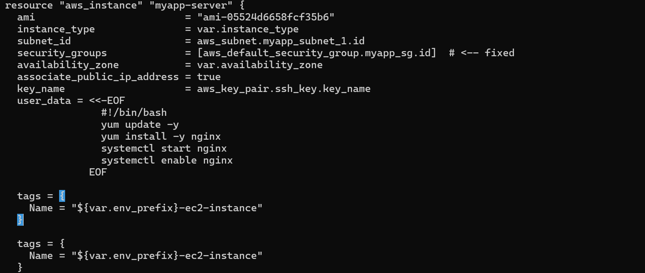

SSH in and run:

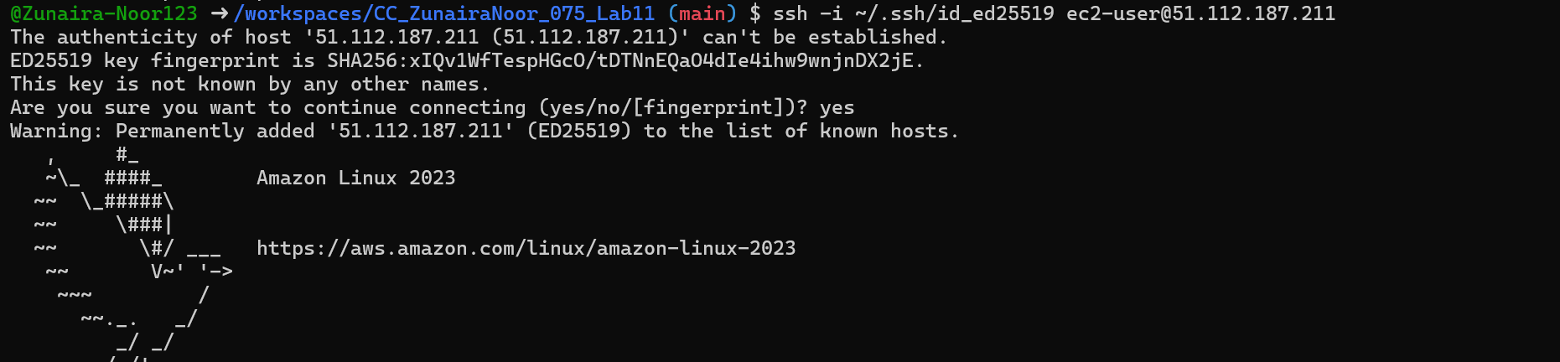

Verify nginx installation (inline user_data or script)

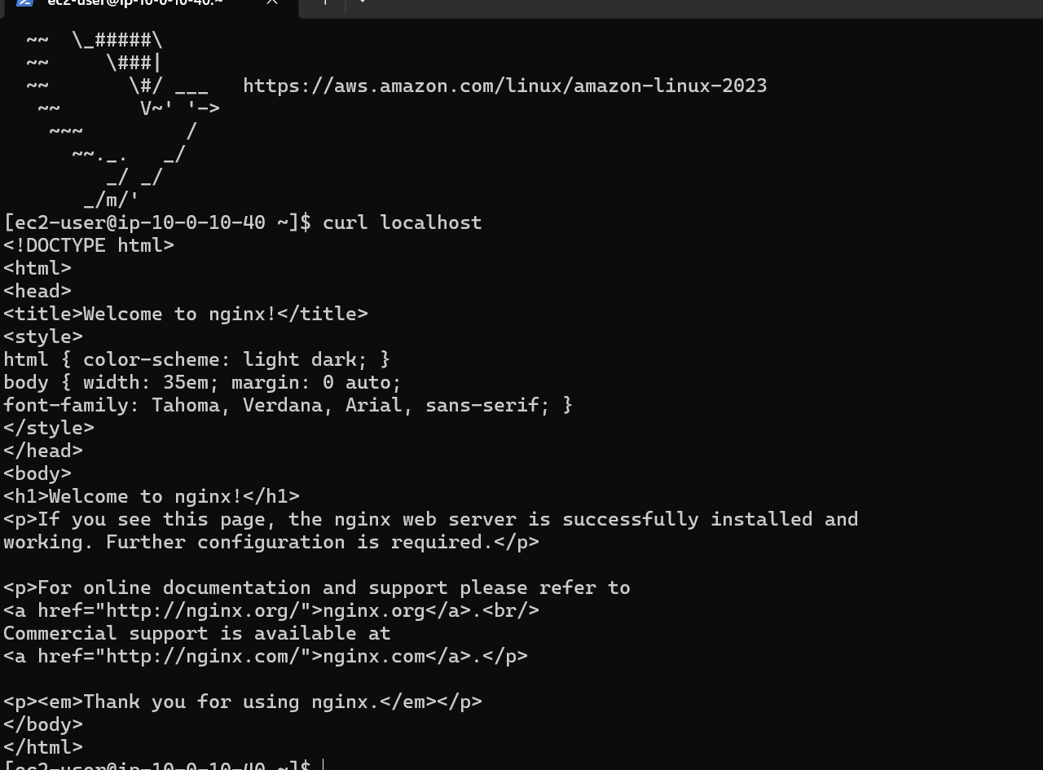

Open in browser

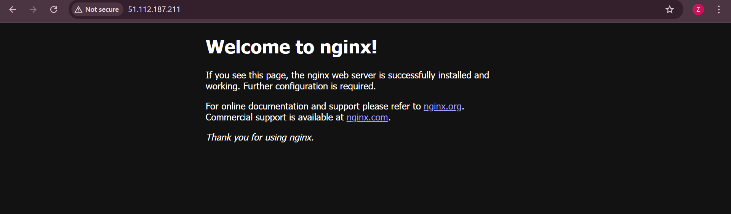

1. Use an external script for user_data Create a script file in the Codespace:

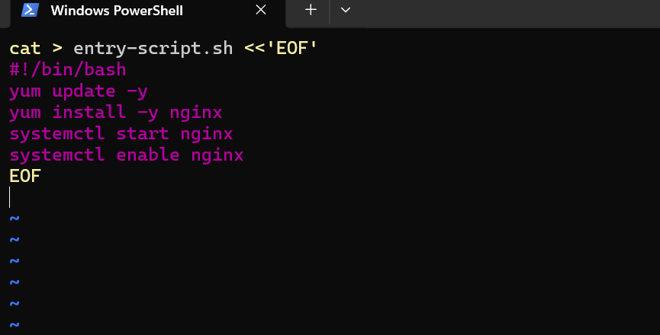

Update aws_instance to use the file:

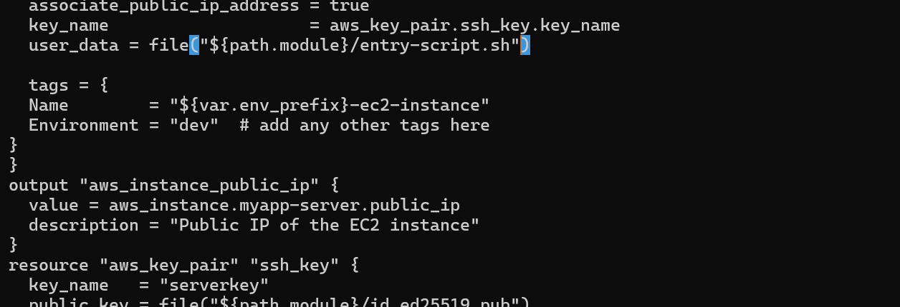

Apply: 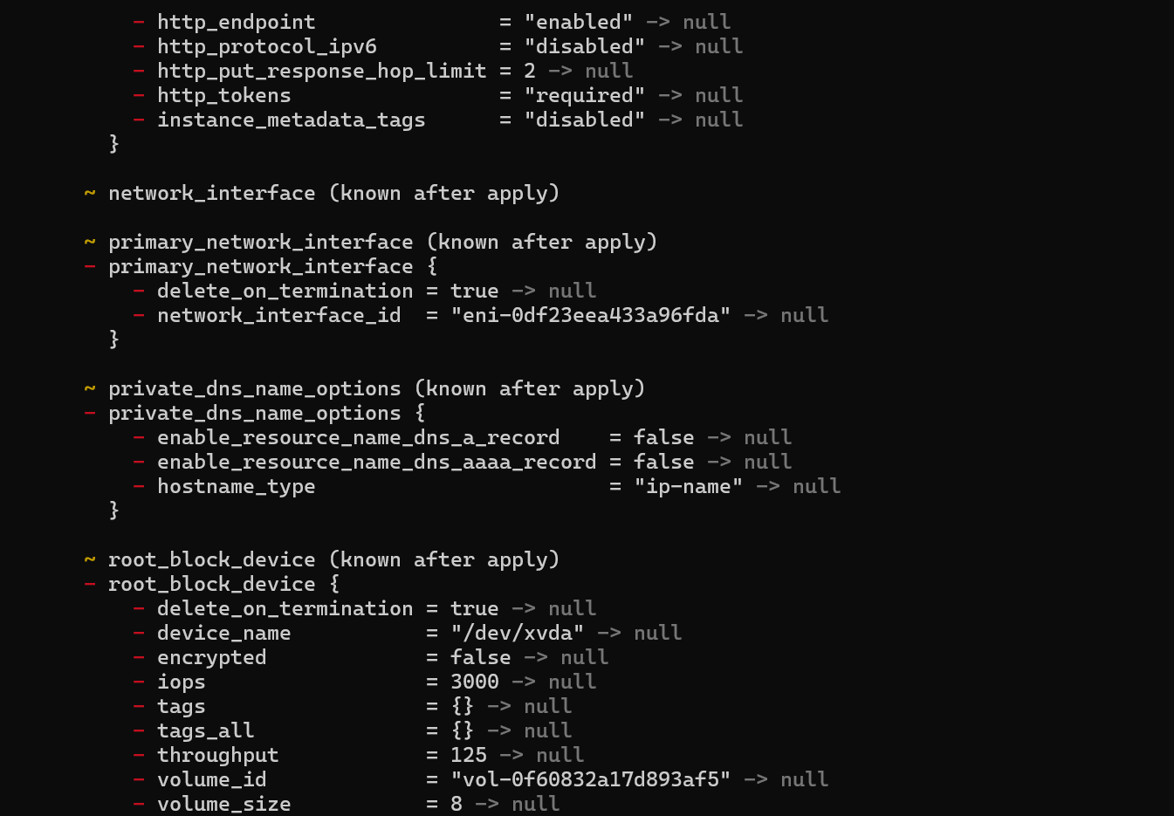

**Cleanup**

1. Destroy all resources:

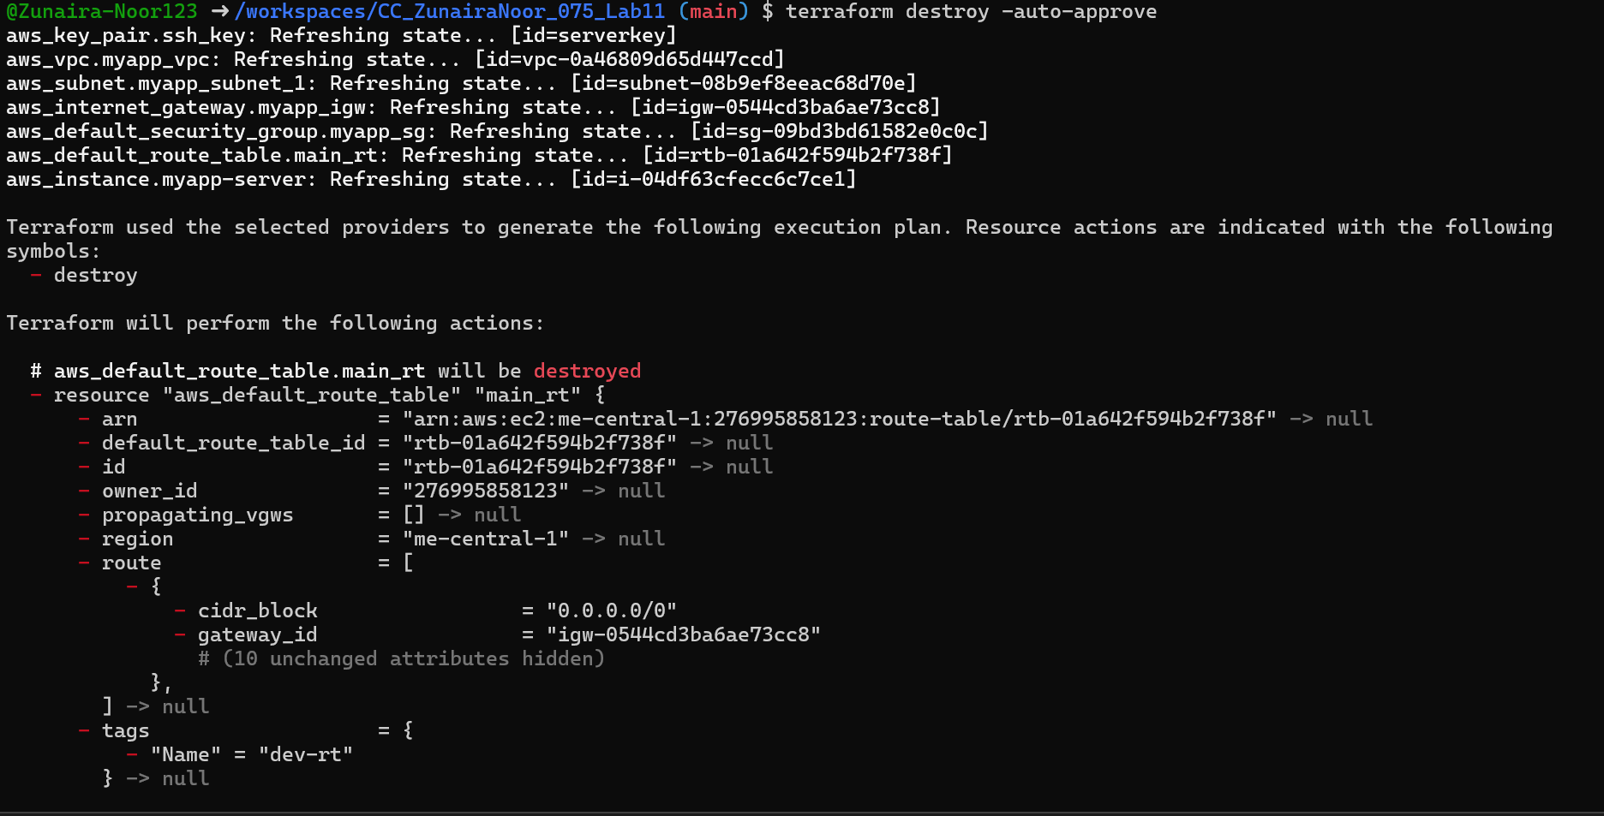

1. Verify state files:

